Dear Valued Business Partner,

Thank you for using BudExchange! This secure tool was designed with you, our business partner, in mind. It allows you to access payment status, submit invoices, and sign up for electronic payments online anytime! We have included brief instructions to assist you with enrolling. Once enrolled, you will receive a user ID and password via email and be able to access your account 24/7.

Going forward, please use BudExchange as your primary channel for inquiries and information regarding your account. Our website also provides the opportunity to contact us directly with your questions.

Again, thank you for enrolling in BudExchange and for your ongoing partnership with Anheuser-Busch InBev. We appreciate your support.

Sincerely,
Your Friends at Anheuser-Busch InBev
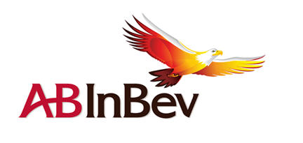
In this document you will learn:
- How to register for BudExchange access………………………………………………………..…………………2-7
- How to view a list of open purchase orders (PO’s)………………………………………….………..….....8-9
- How to submit an invoice (4800 PO’s only) …………………………………..…………………………… 10-11
- How to propose changes to POs…………………………………………………………….………………………….12
- How to check payment status………….……………………………………………..…………………..….…………13
- How to check the status of an invoice…………………………………..……………………………………..…….14
- 450 Purchase Order Information…………………………………………………..………………………………15-16
- How to respond to quotes (eRFQ)…………………..……………………………………………………………..17-21
- How to request assistance.................................................................................................22-26
How to register for BudExchange access
Follow the steps below to request new or additional access for BudExchange. Screenshots are included for your convenience. Please note, Internet Explorer is the preferred browser for use with BudExchange.
- Enter the web address www.budexchange.com in your web browser.
- The following page will appear, click NEED TO REQUEST ACCESS OR CHANGE EXISTING ACCESS. 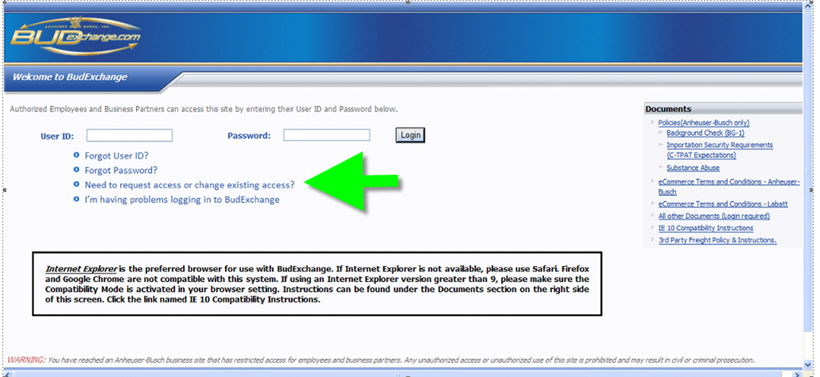
- You will need to determine if you are requesting access for multiple users (fellow colleagues in addition to yourself), or if you just need access for you.
NOTE: Anything marked with a red asterisk is required information.
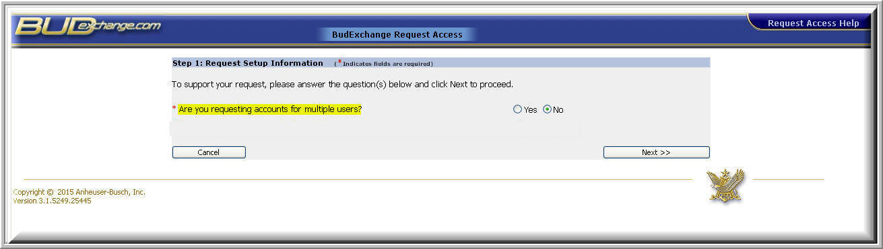
- As the requestor for access, you will need to enter your name and contact information. If you know your AB contact, you may enter their information as well; it is not required but would be helpful if we have any questions regarding your access.
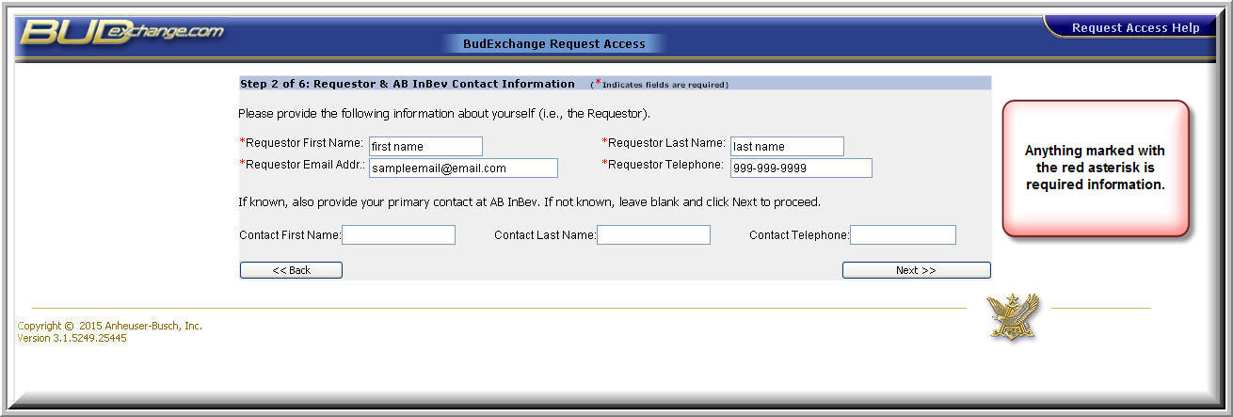
- At identify business function, click drop down and select ACCOUNTING.
- In the next drop down, select ANHEUSER-BUSCH COMPANIES.
- Under applications for which you are requesting access, choose both of the following:
- EPO/EINVOICING: This selection allows you to view PO’s, as well as submit and view invoices and payments.
- eRFQ and OUTLINE AGREEMENT: Allows you to view and respond to electronic requests for quotations.
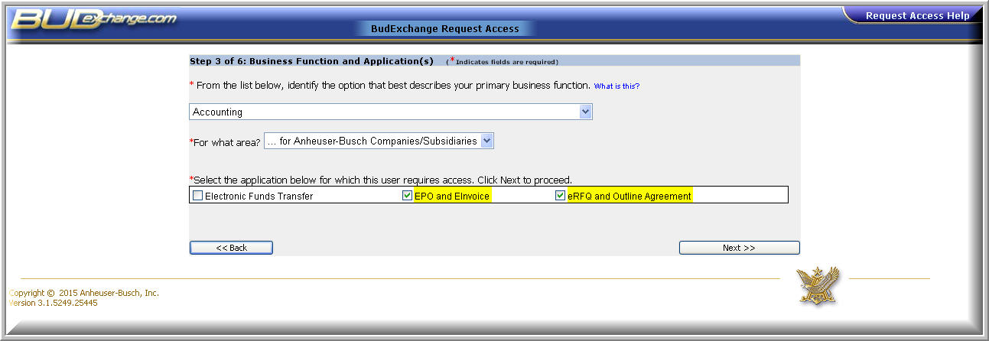
- Enter your company information (company name, region, city, country, and state/providence are required). You can also obtain your SAP vendor # from your AB contact (this is not required to request access, but is strongly recommended in order to expedite the approval process).
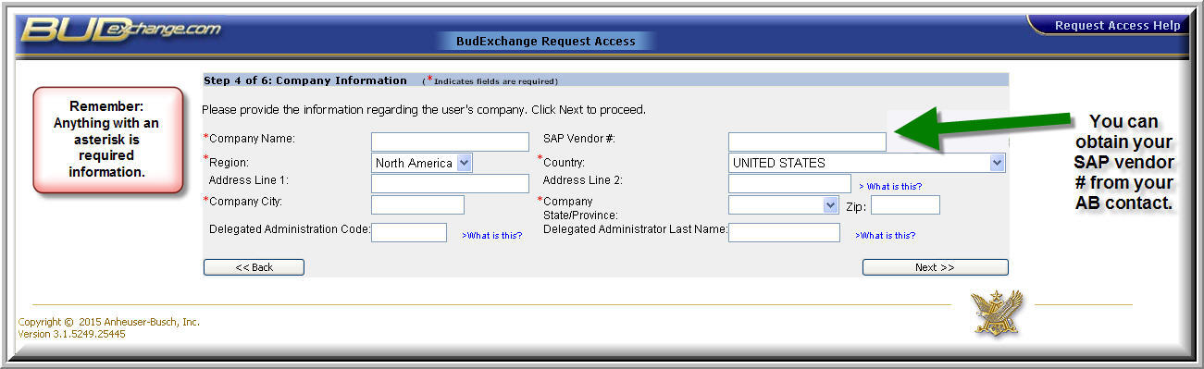
- Enter your user profile information (first name, last name, email address, and phone number are required). If the information is the same as the requestor information, CLICK IF SAME AS REQUESTOR.

- If you want your access to be set up like an existing BudExchange User’s access within your company, select “yes” and enter the BudExchange User’s ID.
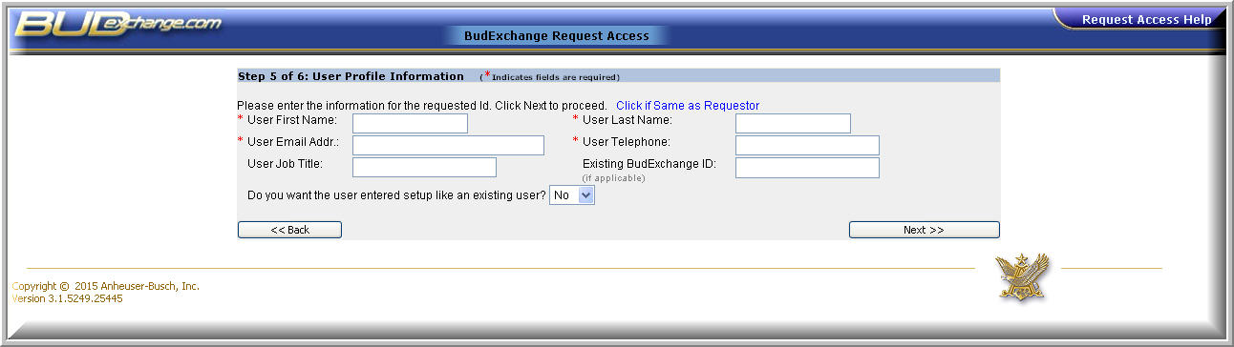
- Review the request for accuracy; you will not be able to make changes once the request is submitted. If you feel no changes need to be made, enter the pin code (located in the black box), enter any notes you feel would be helpful for the approver, and click submit.
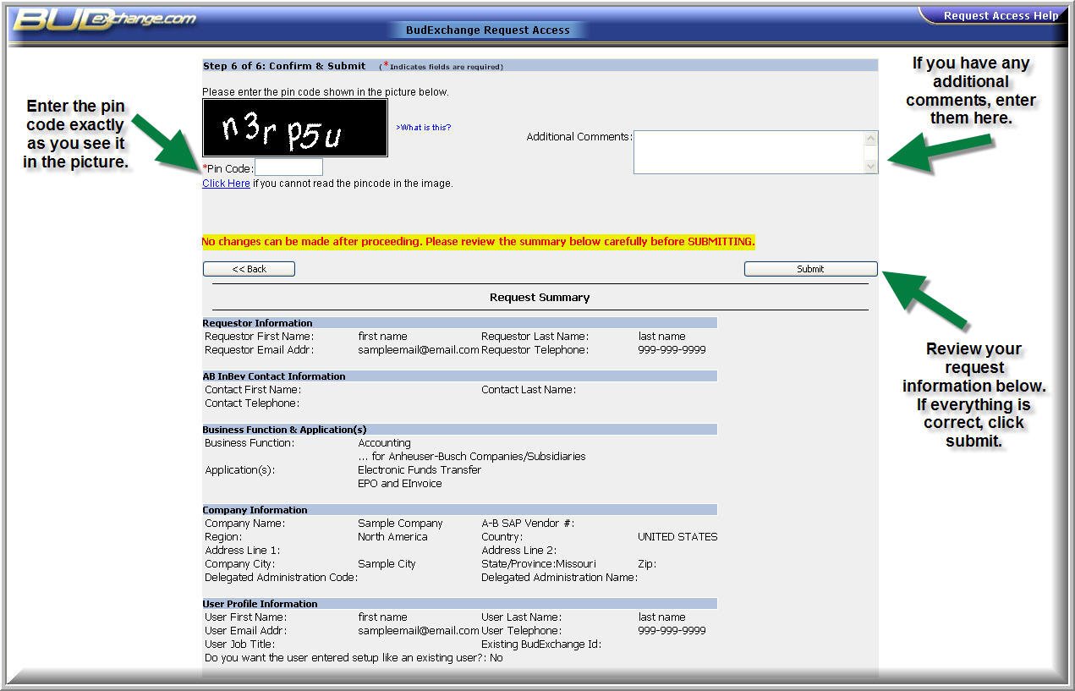
Note: Changes cannot be made after submitting. If changes are needed, click the back button until the information to be changed is displayed. Enter the information and click next to proceed to the “confirm and submit” screen.
- Click finished. You will be presented with a confirmation number, please make note of this number. Your request will then be routed to Anheuser-Busch InBev for approval. Requests are handled within approximately 5 business days. You will then be notified by email with your login ID and password if your request is approved. If your request is rejected, you will also be notified via email.
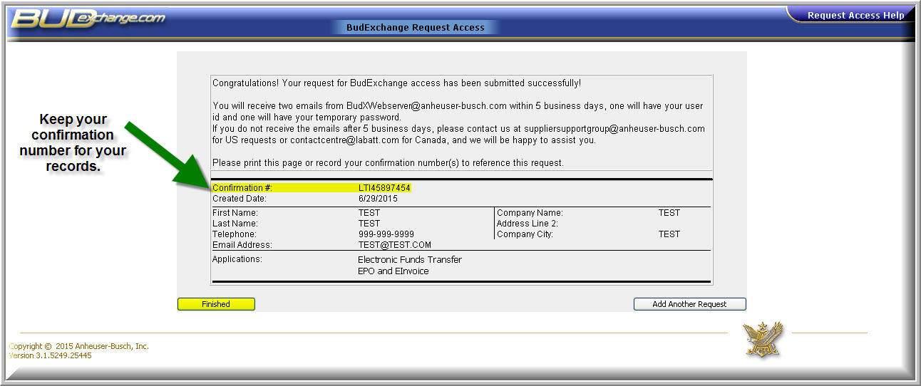
Note: If you do not receive your login ID and password within 5 business days, please submit a request to us by clicking on the link “I’m having problems logging in to BudExchange” from web address www.budexchange.com and provide your confirmation number.

How to view a list of open
purchase orders (PO's)
- Log onto https://www.budexchange.com.
- Click on APPLICATIONS near the top.
- Click on EPROCUREMENT in the first drop-down menu.
- Click on EPO/EINVOICE in the next drop-down menu.
- Click in the PO # SEARCH box and enter your 10-digit PO number without the letters in front, then click GO.
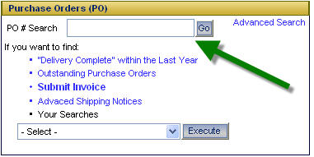
- Once the purchase order populates, double click on the PO number and the PO details will display.
- Check the details of the PO for accuracy. Be sure to check the price, quantity, delivery date, and material number. If changes are needed, you may propose changes to the PO and your proposed changes will route directly to the buyer for the PO. To request changes to your PO, please follow the instructions in the How to propose changes to Purchase Orders (POs) section.
- You may also download a copy of the PO by clicking the VIEW AS PDF button.
- To view a list of all your POs, click the Outstanding Purchase Orders link.
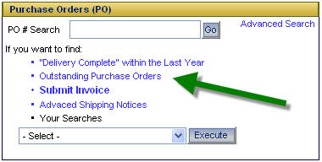
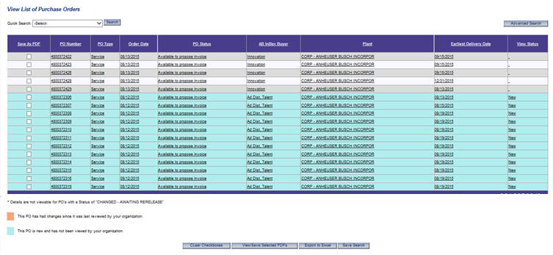
Note: Each PO is color-coded to identify if the PO is new or not yet viewed (blue), changed since the PO was last viewed (orange), or previously viewed and not changed since it was last viewed (no color coding).

Click on the PO line to view the details of the PO. You may also download a copy of the PO from this screen as well.

The PO status indicates if the PO is available or not to propose invoices against.

Note: Invoicing is only allowed on service POs which begin with 4800.
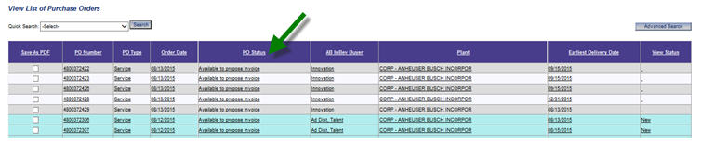

Before logging into BudExchange, make sure that your invoice(s) is saved on your computer in the supported format (.pdf, .doc, .jpeg, or .xls) with no special characters in the file name.
How to submit an invoice
(4800 PO's only)
- Log onto www.budexchange.com.
- Click on APPLICATIONS near the top.
- Click on EPROCUREMENT in the first drop-down menu.
- Click on EPO/EINVOICE in the next drop-down menu.
- Click on the PO # SEARCH box and enter your 10-digit PO number without the letters in front, then click GO.
- Once the purchase order populates, double click on the PO number and the PO details will display.
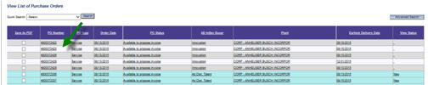

- On the Purchase Order Detail page, click the PROPOSE INVOICE button (outlined in red).
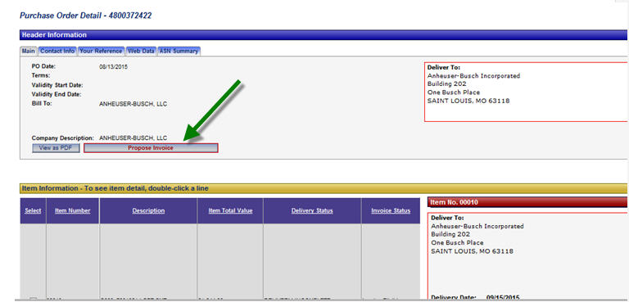
- Enter the following information (required fields will be highlighted in red):
- Invoice amount
- Your reference number (invoice number)
- Invoice date MM/DD/YYYY
- Note: If your invoice date is more than 5 days prior to the current date, AB’s system will change the invoice date to be no more than 5 days from the current date once the invoice has been submitted and transferred to our SAP payment system. You will be presented with a warning message advising you of this.
- Please pay attention to the payment terms and tax instructions presented on this screen. The terms will be used to calculate the payment due date based on the invoice date (or adjusted invoice date if older than 5 days from the entry date). The tax instructions let you know if tax will be applied and if the system expects to pay tax directly to the vendor or to the state.
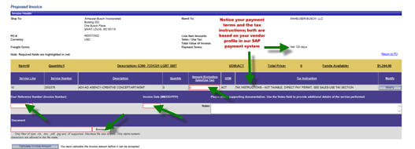
- Attach a copy of your invoice by selecting BROWSE (if using Safari, it will say CHOOSE FILE).
- The file must be in a supported format (.pdf, .doc, .jpeg, or .xls)
- The file size must be less than 8MB.
- The file name cannot include any special characters, spaces, commas or decimals.
- Click CALCULATE INVOICE AMOUNT near the bottom left and choose Yes or No when it presents the calculated payment amount.
- If YES: The system should give you pop up box that directs you to click on the link RETURN TO PO. Once back on the PO detail screen, scroll down and click on the invoice status tab. If your purchase order has more than one line item, make sure you highlight the appropriate line item that you submitted your invoice on BEFORE you click on the invoice status tab. Your invoice should be listed as a service entry with the status of IDOC POSTED. This status confirms your invoice submitted correctly.
- If you do not agree with the calculated amount, click NO and submit a ticket on BudExchange by clicking the red NEED ASSISTANCE button in the upper left corner of the screen.

How to propose changes to purchase orders (POs)

- Log onto www.budexchange.com.
- Click on APPLICATIONS near the top.
- Click on EPROCUREMENT in the first drop-down menu.
- Click on EPO/EINVOICING in the next drop-down menu.
- Click in the PO# SEARCH box and enter your 10-digit PO number without the letters in front and click GO.
- Once the purchase order populates, double click on the PO number and the PO details will display.
- Check the details of the PO for accuracy. Be sure to check the price, quantity, delivery date, and material number.
  - To propose a change to the PO, click the REQUEST CHANGES button near the bottom of the screen. Input the changes and click the Save Changes button; the request will then route to the AB buyer. The buyer will either approve or reject the change(s) and you will be notified via email. Approved changes will automatically update your PO and you will see the revised PO in BudExchange. Rejected changes do not alter the PO.
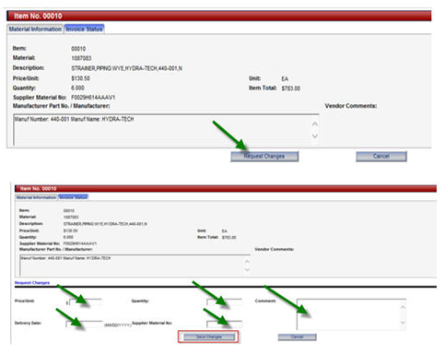
How to check payment status
- Log onto www.budexchange.com.
- Click on APPLICATIONS near the top.
- Click on EPROCUREMENT in the first drop-down menu.
Invoices that have not paid:
- Click on INVOICES SCHEDULED FOR PAYMENT. Here you will find invoices that have been approved for payment but have not paid yet. The due date shown is the calculated date based on your payment terms and your payment frequency.
- You can drill into any specific payment to see the details or you can download an entire list of pending payments.
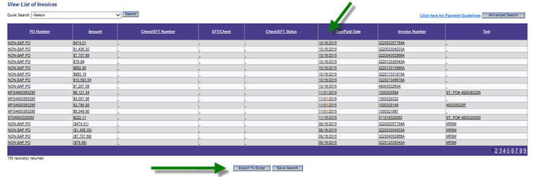
Invoices that have already paid:
- Click RECENTLY PAID INVOICES (either 30, 60, 90, or 180 days) for invoices that have already paid. Here you will find payment information such as the payment date, amount, check number, etc.
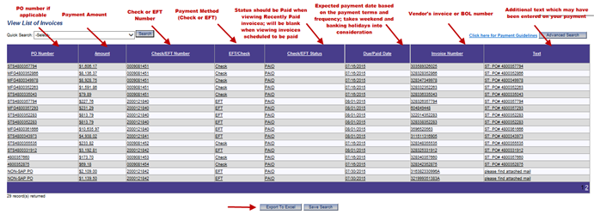
Note: To inquire on payments older than 180 days, please submit a ticket to the Supplier Support Group by clicking the Need Assistance button in the upper left corner of the screen.
How to check the status
of an invoice
If you did not find the payment status you were seeking under INVOICES SCHEDULED FOR PAYMENT, you can check the status of the invoice by doing the following:
- Click on APPLICATIONS near the top.
- Click on EPROCUREMENT in the first drop-down menu.
- Click on EPO/EINVOICE in the next drop-down menu.
- Click on the PO # SEARCH box and enter your 10-digit PO number without the letters in front, then click GO.
- Once the purchase order populates, double click on the PO number and the PO details will display.
- From the Purchase Order Detail page, scroll down and select the INVOICE STATUS tab. If your purchase order has more than one line item, make sure you highlight the appropriate line item that you submitted your invoice on BEFORE you click on the invoice status tab. This is where you will be able to view the status of your invoice. Your invoice status will be one of the following: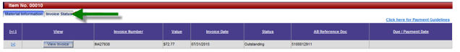

- IDOC POSTED – Your invoice was successfully submitted and the system has not yet updated since you posted the invoice (the systems update twice an hour).
- PENDING REQUISITIONER ACCEPTANCE – The system updated, and your invoice is awaiting approval from the requisitioner.
- OUTSTANDING – Your invoice has been approved and is scheduled for payment. (You can view the payment date under INVOICES SCHEDULED FOR PAYMENT).
- PAID – Your invoice has paid. (You can view the payment details under RECENTLY PAID INVOICES).
- IDOC AP ERROR – Your invoice has a posting error. The Anheuser-Busch payment team reviews these errors every day and corrects and reposts them when possible. You or the buyer associated with the PO may be contacted if information is needed from you for us to resolve these errors. If your invoice remains in this status for more than 5 business days, please submit a request via our NEED ASSISTANCE option in BudExchange to have this fixed. Please include the PO# you submitted the invoice under, the invoice number and amount, and your BudExchange user ID.
If you do not see your invoice listed, it means your invoice was not submitted successfully. Please re- submit your invoice.
450 purchase order information
Payments for purchase orders that begin with a “450xxx” are typically made via Evaluated Receipt Settlement - otherwise known as ERS. This is a method for paperless settlement with suppliers where payment is based upon the date the goods receipt was entered AND the quantity of goods/materials received in lieu of a paper invoice. The amount paid is calculated from the quantity which is received multiplied by the price on the purchase order as of the date of the receipt. If you see that there is a discrepancy on the price or quantity, please reach out to the buyer listed on the PO. You can also dial 314-577-2000 which is our corporate operator number where you can reach them by first and last name.
Please note we do not pay from your paper invoice copy, therefore; you would NOT submit invoices on these types of purchase orders, but you can check payment status on our portal for these payments.
TO CHECK PAYMENT STATUS ON INVOICES for 450 PURCHASE ORDERS:
- Log onto www.budexchange.com.
- Click on APPLICATIONS near the top.
- Click on EPROCUREMENT in the drop-down menu.
- Click on EPO/EINVOICING in the next drop-down menu.
- From the EPO/EINVOICING page, click on INVOICES SCHEDULED FOR PAYMENT. This will provide a listing of all invoices that are scheduled with a future payment date.
If you want to view recently paid invoices, you may click on the link (depending on the date range you want to view) under “recently paid invoices”.
You may also view payment status for 450 POs within the PO detail screen:
- Click on APPLICATIONS near the top.
- Click on EPROCUREMENT in the first drop-down menu.
- Click on EPO/EINVOICING in the next drop-down menu.
- Click on the PO # SEARCH box and enter your 10-digit PO number without the letters in front, then click GO.
- Once the purchase order populates, double click on the PO number and PO details will display.
- From the Purchase Order Detail page, scroll down and select the INVOICE STATUS tab. This is where you will be able to view the status of your invoice.

- The list of PO lines above the INVOICE STATUS tab will indicate if the material has been delivered (received in our system). If the Delivery Status shows Delivery Complete, the goods have been received and should be scheduled to pay. If the Delivery Status shows Delivery Incomplete, AB has not yet processed the receipt for the materials. If you have already delivered the materials associated with the PO line which indicates Delivery Incomplete, please contact your AB business contact to ensure they perform the goods receipt in our system.
Note: payment cannot be scheduled until the good receipt has been performed in the AB system.
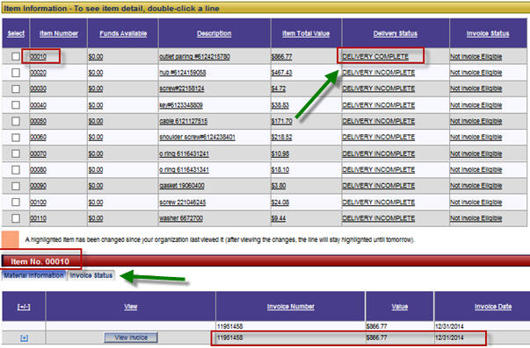
If you do NOT find your payment scheduled for a 450 purchase order, please contact your requisitioner or AB contact to ensure the good receipt or service acceptance has been completed. If you need information on who to contact, please forward us a copy of the proof of delivery along with your invoice that references the purchase order number so we can escalate it to the receiving location to complete the goods receipt. Once receiving is completed in the system, your payment will generate. You can send these documents via the NEED ASSISTANCE option in BudExchange.

When an RFQ (request for quote) is created by the AB buyer, an email is then sent to the supplier/vendor. Emails are sent to users with BudExchange access and are based on the vendor number associated with the account.
RFQs (Request for Quotes) in BudExchange

Note: Users can receive RFQs for all AB locations or only the ones they service.
Example of what an RFQ email will look like:
- Log into www.budexchange.com.
- Click on APPLICATIONS at the top.
- Click on EPROCUREMENT in the drop-down menu.
- Click on ERFQ in the next drop-down menu.
- The ERFQ SUMMARY SCREEN shows new, saved, rework, and past due RFQs. Click on the plus sign next to the category you wish to view.
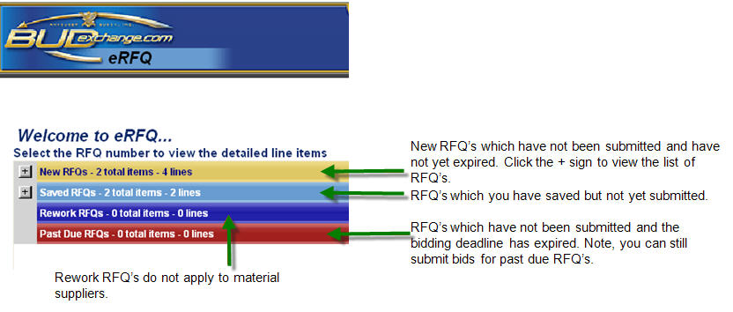
- In the list of available RFQs, click on the RFQ number to view details.
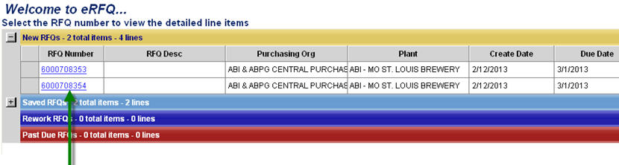
- The request contains two sections: header information and quote details.
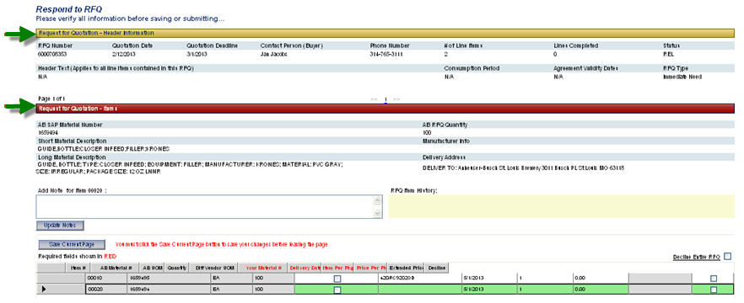
- Click on the line to see the details of the RFQ. You can also export to Excel using the button at the bottom of the screen (see screenshot).
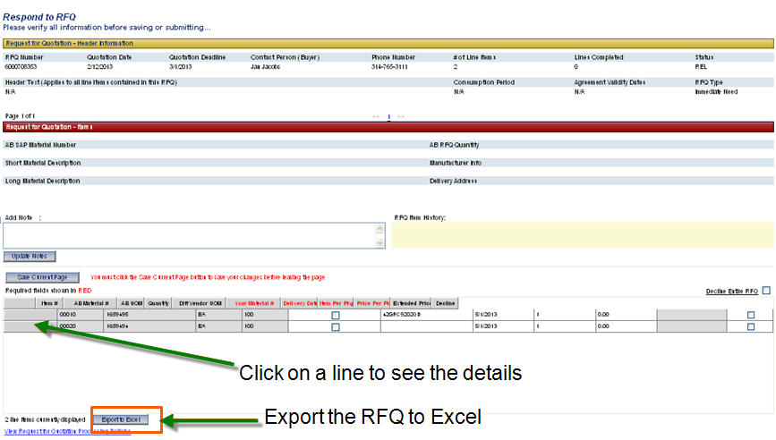

- Review the details of the quote. There are two methods of responding to an RFQ. You may respond by bidding on an item, or you may respond by declining to bid. Each item on the RFQ must be responded to, and you can save your bids as often as needed before submitting. Once you have responded to all items in an RFQ, you may submit it.
To bid on an item, click on the line. Required fields are shown in red.
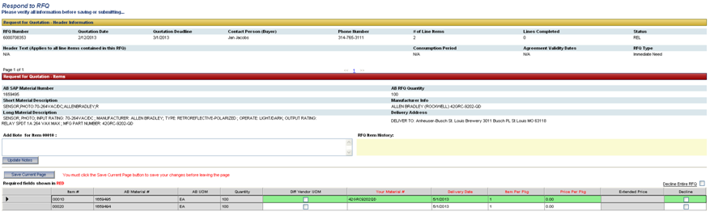
Diff Vendor UOM: See next page
Your Material #: Validate your material number and enter the correct number if applicable.
Delivery Date: Enter expected delivery date.
Item Per Pkg: Enter the quantity that comes per package.
Price Per Pkg: Enter your price per package.
Note…if you have any issues with the part number or quantity, you should decline the quote and enter notes to the buyer.
- Different Unit of Measure: If your UOM differs, check the Diff Vendor UOM box. Information will be presented above the line to allow you to change the UOM. Use the drop down menu to select a different UOM. Enter the price for the UOM. Input text to the buyer.
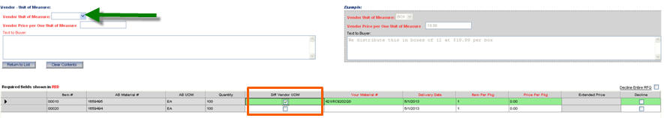

- You can enter notes specific to a line or lines. IMPORTANT…notes you enter will not be emailed to the buyer. If you need to enter notes for the buyer, you should enter the notes and decline the quote. This will allow the buyer to see your notes. Once the required fields have been completed for all lines on the RFQ, click the Save Current Page Button.
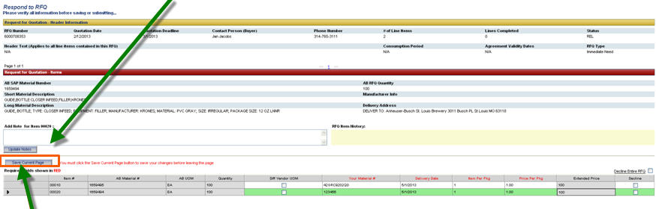
- Once you have saved the RFQ a Submit Final Quote Button appears. Click this button to submit the quote.
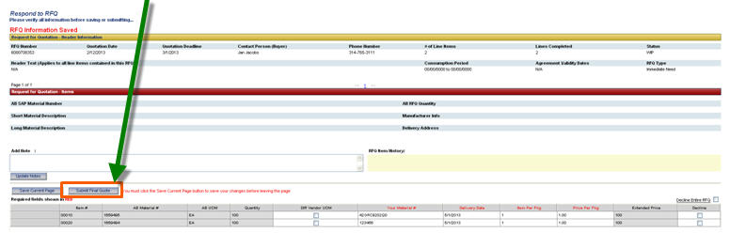
- After clicking the Submit Final Quote button, this message should appear.
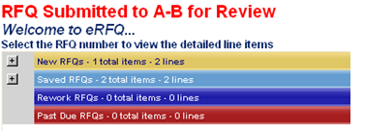

- To decline all of the line in an RFQ, click the Decline Entire RFQ checkbox. To decline individual lines on an RFQ, click the Decline checkbox for the applicable lines.
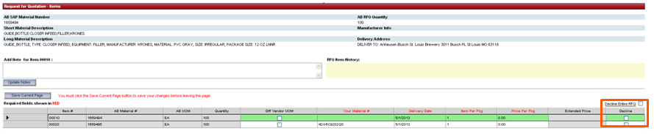
- To decline the entire RFQ, see screenshot below.
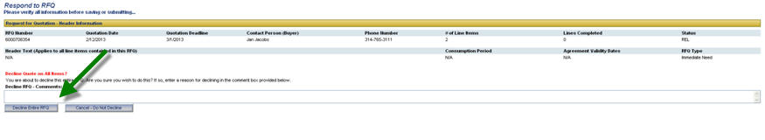
- To decline certain lines on the RFQ, see screenshot below.
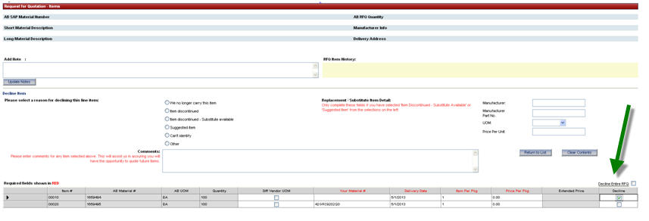

Need Assistance?
- Log onto www.budexchange.com.
- Click on APPLICATIONS near the top.
- Click on EPROCUREMENT in the drop-down menu.
- Click on EPO/EINVOICING in the next drop-down menu.
- In the top left-hand corner, click the red NEED ASSISTANCE? button. The FAQ page will then open in a new window.
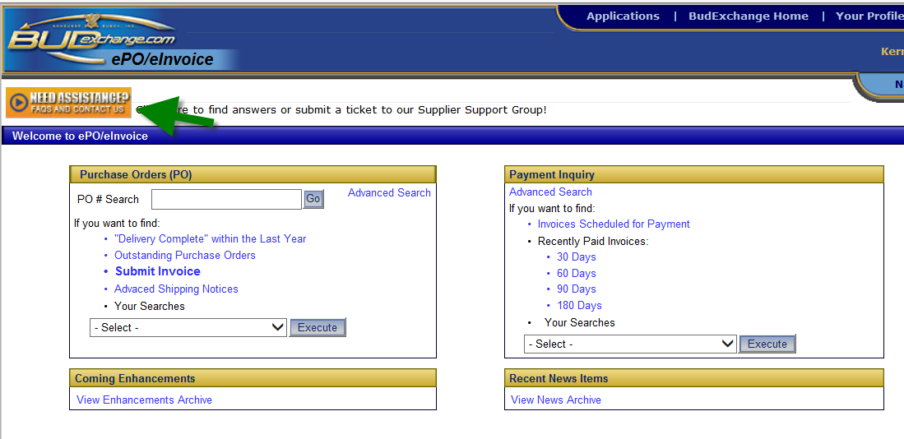
- To view the FAQ’s, select the plus sign to expand the category you need assistance with.
- If you do NOT find the information you are looking for or if you still need assistance, click the CONTACT US FOR ASSISTANCE box on the left.
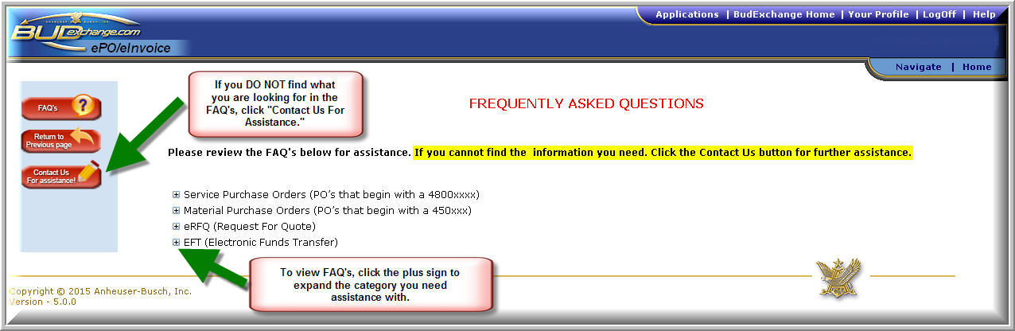

- In order to submit a request via BudExchange, enter your vendor ID number (which will automatically populate based on your user ID), email address (required), country of support, and language.
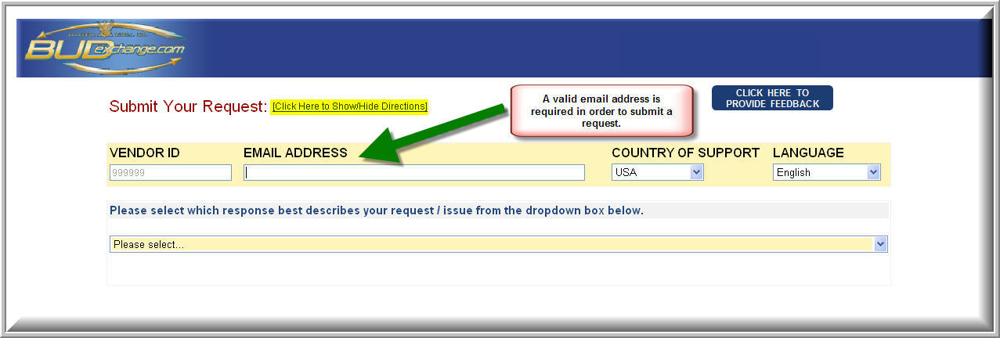
- Once you have entered your information, click the arrow on the first drop down and select the category that your inquiry pertains to.
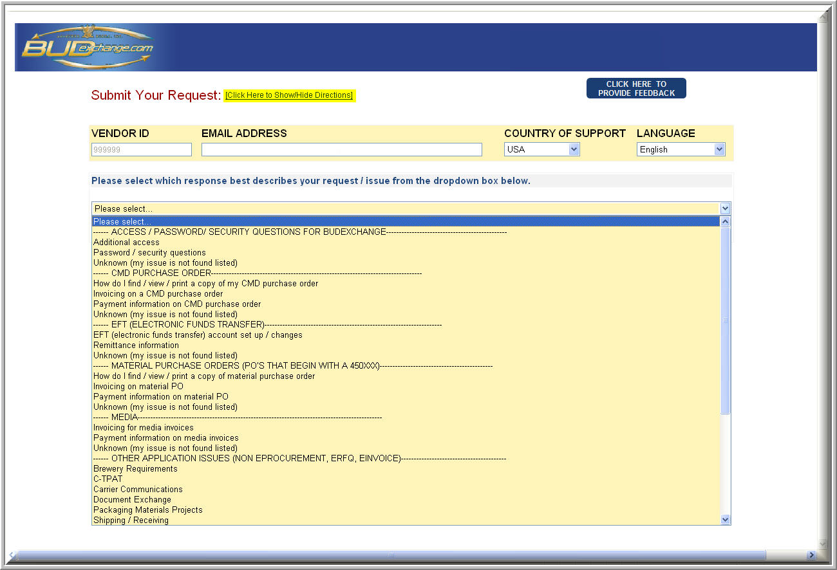

- After selecting the category in the first drop down, click the second drop down and select the detail that pertains to your inquiry.
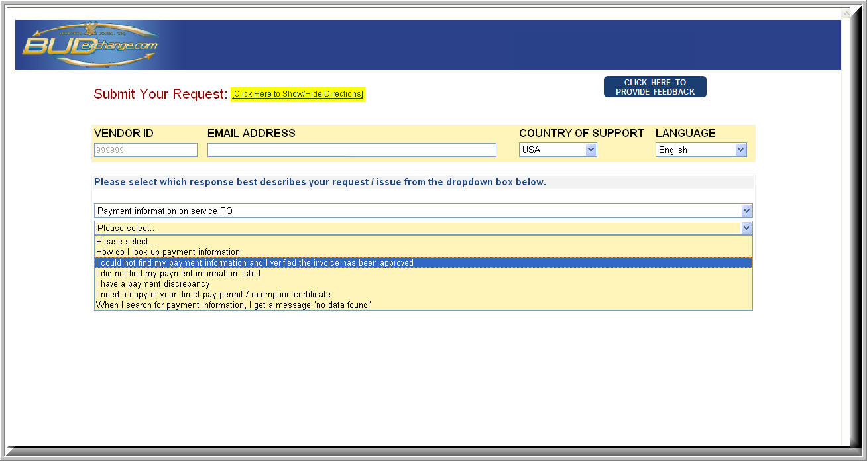
- If your selection is something that is covered in the FAQ’s, a link will appear directing you to the correct FAQ section that will address your question (see detail below).
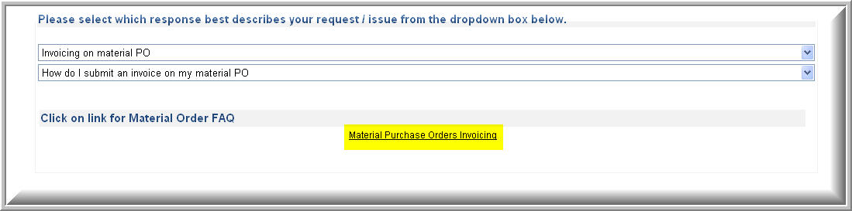

- If your selection is not covered in the FAQ’s, you will then be able to submit all the necessary details regarding your request, along with an attachment. Once you have reviewed the details of your submission, click submit.
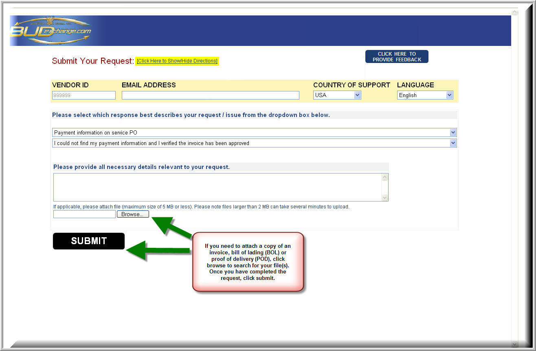
Note: You can also provide feedback regarding our BudExchange site and self-ticketing tool by utilizing the CLICK HERE TO PROVIDE FEEDBACK link located in the top right corner of the page.
- Once you submit your request, it will be routed to the appropriate department and a specialist will begin working on your issue.

