Internet Explorer Compatibility Mode

If you are using Internet Explorer Version 10 and are having issues, please make sure to activate the “compatibility mode” by selecting the below shown button.

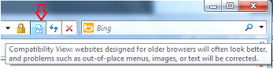

If this button is not viewable, the compatibility option can be accessed from the “Tools” menu. After selecting this, the BudExchange site address will be added to the “Compatibility View Settings List”

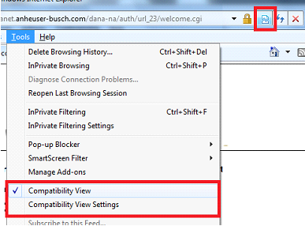

To make sure that the application is already on “Compatibility Mode”, you can select the “Compatibility View Settings” option and you should see the BudExchange site address in the list. If Budexchange.com is not in the list you will need to press the “Add” button:
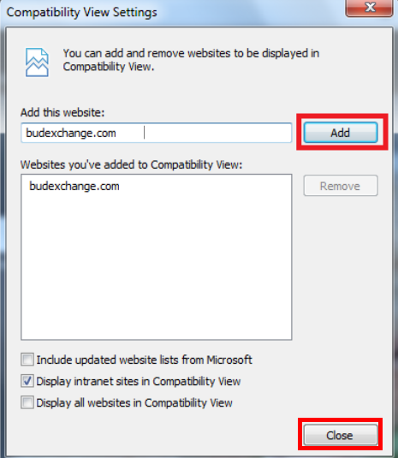

Once added, click the Close button and refresh the page using the Control Key and the F5 key (CTRL+F5).

